Project Design Phase-II
Data Flow Diagram & User Stories

Date | 27 Feb 2026
Team ID | LTVIP2026TMIDS46648
Project Name | Electric Motor Temperature Prediction using AIML
Maximum Marks | 4 Marks

Data Flow Diagrams:
A Data Flow Diagram (DFD) is a traditional visual representation of the information flows within a system. A neat and clear DFD can depict the right amount of the system requirement graphically. It shows how data enters and leaves the system, what changes the information, and where data is stored.
Example: DFD Level 0 (Industry Standard)
Example: (Simplified)
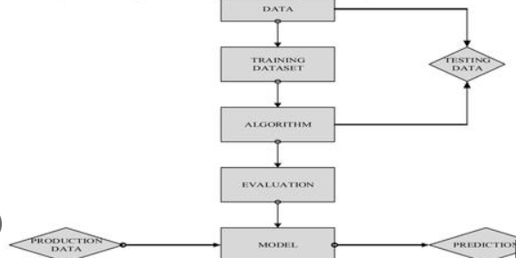
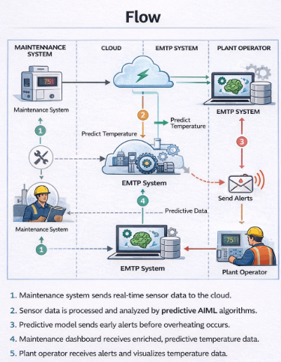

User Stories
Use the below template to list all the user stories for the product.
User Type | Functional Requirement (Epic) | User Story Number | User Story / Task | Acceptance Criteria | Priority | Release
Plant Operator | Real-Time Monitoring | USN-1 | As a plant operator, I want to view real-time motor temperature data. | I can see live temperature readings on dashboard | High | Sprint-1
Plant Operator | Predictive Alerts | USN-2 | As a plant operator, I want to receive alerts before overheating occurs. | I receive notification before temperature crosses threshold | High | Sprint-1
Maintenance Manager | Performance Analysis | USN-3 | As a maintenance manager, I want to analyze historical motor data. | I can view reports & graphs of past temperature trends | High | Sprint-1
Maintenance Manager | Failure Prediction | USN-4 | As a maintenance manager, I want the system to predict motor failures. | System shows early failure warning based on data | High | Sprint-2
Administrator | Data Management | USN-5 | As an administrator, I want to manage sensor data storage. | I can add, update, or delete motor data | Medium | Sprint-2
Administrator | Threshold Settings | USN-6 | As an administrator, I want to set temperature alert thresholds. | Alerts trigger when limit is exceeded | High | Sprint-1
System | Data Logging | USN-7 | As a system, I need to store historical temperature data. | Data is saved in database successfully | High | Sprint-1
Plant Operator | Dashboard | USN-8 | As a plant operator, I want a simple dashboard to monitor motor health. | Dashboard shows temperature, load, voltage & status | Medium | Sprint-2

